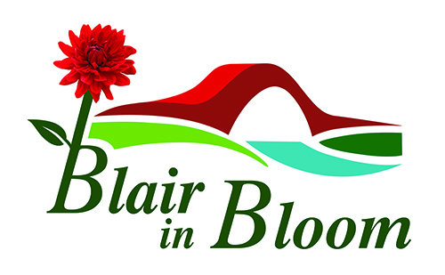

Minutes of Committee Meeting held on

1st May 2023

At 7 Manor Gardens, Blairgowrie PH10 6JS

1 | Those present: Cathy Doe, Pat Lumsden, Morag Reid, Jean Smith, Avril Wilson, William Wilson.
2 | Apologies from: Mary Birch, Cllr Bob Brawn, Cllr Caroline Shiers.
3. | Minutes of last Meeting. Approved by Avril Wilson. Seconded by Morag Reid
4.  5.  6.  7. | Matters Arising:  PKC confirmed funding for hanging baskets was £2000.  Guides written to with Pat as contact name. Lisa Hilditch at Guides would appreciate some advice on planting. Visit to be arranged.  Visit to Kinross Allotment Association and Community Garden. Thanks to Avril for arranging. Lovely day out. Jean to produce brief report on visit.  Polytunnels at Woodlands Road now dismantled and being stored at Rattray Community Garden. Thanks to William for dealing. There are some fruit trees/bushes at Woodlands Road that the lady is happy for us to take but they will have to be replanted immediately they are lifted. Due to more urgent commitments this may not be for a week or two.  Coronation Corner Celebrations – 8TH May 2023  Available Committee members to meet at the Community Garden at 9am to collect plants, tables etc for plant sale. Volunteers being asked to meet around 10am for a chat and a tea or coffee. Plant sale from 10am -12noon. WI sign to be placed back beside tree.  Treasurer’s Report:  £2000 from PKC. £650 left.  £800 spent on plants for Ardblair.  £640 DG Gardens work at Ardblair.  £122 o incidental expenses.  £2509 I Bank.  Income expected from Shopkeepers committed to taking a hanging basket £2460 with another 11 still to confirm.  Money from Tesco blue token scheme – at least £500  Suggested sponsorship for large containers or displays. Pat to speak to Caravan Parks. We should write to large local firms early next year asking if they would care to sponsor containers or large displays.  Swellgel, slow release fertiliser and liquid fertiliser to be ordered asap.  Tasks and Priorities - as attached list.  AOCB:  Bank signatories now dealt with. Jean and Morag awaiting bank cards.  Mural - no further word. Will follow up if nothing heard in next couple of months  Pop Up Shop - nothing further at present.  Victoria Community Garden Visit - Jean to arrange in due course.  Watering of baskets and rota. – William and Avril to write to other organisations who may be willing to help with the watering. On their return from holiday they will start to put together a rota for watering once the baskets are hung.  More volunteers - it is hoped we may encourage more people to join at our Coronation Celebration. A form with brief details of what we are about with a space for new volunteers details to be produced.  More volunteers required on Committee. Committee members will approach some of the volunteers.  A suggestion of having a leaflet with a Bloom in Blair trail on it with a map of our sites throughout the Town and a little information on each was met with enthusiasm. We could approach local businesses such as tea rooms to have a mention on the map for a small fee. Work on this may be put on back burner for now as it is a busy time of year but could be in place for next year.  Posters for plant sale on 5th June to be printed off and ready for mid May. Committee members to distribute amongst local businesses.  Ask Mary to request plants to sell on Facebook page. Also Mary to tell us who we collect plants from locally.  Request for memorial shrub to be placed in Coronation Corner is granted on the condition there is no plaque. Jean to write to confirm.  Benches in Coronation Corner to be installed. Need to contact contractor.  Date of Next Meeting: Monday 5th June. Time and place to follow. | CD  JS  CD  PL/JS/MR/CD  PL  MR  JS  AW/WW  CD  JS/CD  CD  MB  JS  WW  CD

